Marketing and Sales Management
Level -IV
Based On November 2023 Curriculum Version II
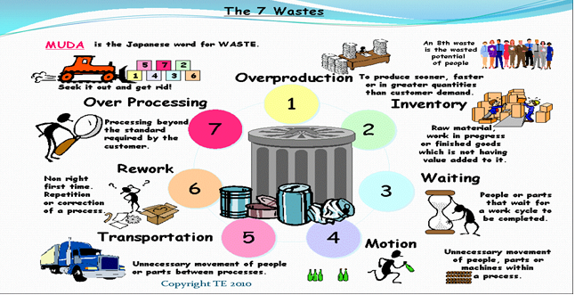
MODULE TITLE: Preventing and Eliminating MUDA
MODULE CODE: LSA MSM4 M12 1123
NOMINAL DURATION: 40HRS

Prepared by: Ministry of Labors and Skills

November, 2023
Addis Ababa, Ethiopia

Acknowledgment
Ministry of Labor and Skills wish to extend thanks and appreciation to the many representatives of TVT instructors and respective industry experts who donated their time and expertise to the development of this Teaching, Training and Learning Materials (TTLM).

Table of Contents
Introduction to the module 7
Unit one: Prepare for work 8
1.1 OHS Requirements, and Safety equipment and tools 9
1.1.1 Definitions of OHS Requirements 9
1.1.2 Types of Hazards 11
1.1.3 Safety equipment and tools 11
1.2 Work instructions 13
1.2.1 Job requirements 14
1.2.2 Procedures vs. Work Instructions 15
1.3 Working manual 16
1.3.1 Job Specification 16
1.4.1 Best practices for choosing materials 17
Self-Check-1 18
Unit Two: MUDA and its problem 19
2.1 Plan of MUDA 20
2.1.1 Definition of MUDA 20
2.1.2 Types of MUDA 20
2.1.3 Concept of Planning 21
2.2 Visual Management Board/Kaizen Board 21
2.2.1 Definition 21
2.3 Tools and techniques to draw and analyze situation of the work place 23
2.3.1 Definitions of work place 23
2.3.2 Plant Layout 23
2.3.3 Process flow 24
2.3.4. Tools and Equipment for Waste/Muda Identification 26
2.4. Causes and effects of MUDA 26
2.4.1 Causes of Muda of Overproduction 26
2.4.2 Causes of MUDA of Inventory 27
2.4.3 Causes of MUDA of motion 28
2.4.4. Causes of MUDA of Conveyance/Transportation 28
2.4.5. Causes of MUDA of Waiting/ Idle time 28
2.4.6. Causes of MUDA of Defect making 29
2.4.7. Causes of Muda of Processing 29
2.5. Statistical tools and techniques /Kaizen elements 30
2.5.1 Seven basic QC Tools 30
2.6 Relevant procedures for wastes/MUDA Identification 35
2.6.1 Benefits of identifying MUDA 35
2.6.2 Plan and procedure for Waste/Muda Identification 35
Self-check-2 50
Unit Three: Analyze causes of a problem 52
3.1. Possible causes of a problem 53
3.2. Cause relationships using 4M1E 53
3.3. The root cause of the problem 56
3.3.1. Definition of root cause 56
3.4. Creative idea generation to eliminate most critical root causes 58
3.4.1. Definition of idea generation 58
3.4.2. Elements of creative idea generation 58
3.4.3. Idea generation methods 58
3.5. Summaries of the Action Plan 60
3.5.1. Concepts of Action Plan 60
3.5.2. Writing an Action Plan 61
Self-check-3 63
Unit Four: Eliminate MUDA and Assess effectiveness of the solution 65
4.1 Plan of MUDA elimination by medium KPT members 66
4.1.1 Muda elimination 66
4.1.2 Ways to reduce waste 66
4.2 Tools and techniques to eliminate wastes/MUDA 67
4.2.1 Adopting the Necessary Attitude 67
4.2.2 The Ten Basic Principles for Improvement 68
4.2.3 Elimination of the seven types of Wastes/Muda 68
4.3. Report improvements 71
4.3.1 Definition of reporting 71
4.3.2 Purpose of reporting 71
4.3.3. Types of report 71
4.3.4. Good report 71
4.3.5. Characteristics of Good or Essential report 72
Self-check-4 73
Unit Five: Prevent occurrence of wastes and sustain operation 74
5.1 Plan of MUDA prevention 75
5.1. 1 Five Key Concepts for Asking “Why” and “How” 79
5.2. Standards required for machines 80
5.2.1. Total Productive Maintenance (TPM) 80
5.2.2. Factors affecting equipment effectiveness 82
5.2.3. Cycle Time and Set-Up Reduction 82
5.2.4. The Equipment Losses 83
5.2.2 Types of maintenance 86
5.3 Prevent occurrences of wastes/MUDA 87
5.4 Create waste-free workplace 88
5.4.1 5W and 1H 88
5.4.2 Benefits of Addressing Waste 89
5.5 Standard procedures and practices 90
5.5.1 Standard Work in Practice 90
5.6 Build capability of the work team 91
5.6.1 Teamwork approach 91
5.6.2 Team works principles 92
5.6.3 Team structures and characteristics 92
Self-check-5 93
Reference 95

Introduction to the module
In mechanics filed; prevention and elimination of MUDA helps to prevent and eliminate wastes by applying standard procedures and methods. The primary purpose of eliminating waste is maximizing the product of an organization.
This module is designed to meet the industry requirement under the mechanics occupational standard, particularly for the unit of competency: Prevent and Eliminate MUDA
This module covers the units:-
- Prepare for work
- MUDA and its problem
- Causes of a problem
- Elimination of MUDA and Assessment effectiveness of the solution, and
- Prevention occurrence of wastes and sustain operation
Learning Objective of the Module
- Preparing for work
- Identifying MUDA and problem
- Analyzing causes of a problem
- Eliminating MUDA and Assessing effectiveness of the solution, and
- Preventing occurrence of wastes and sustaining operation
Module Instruction
For effective use this modules trainees are expected to follow the following module instruction:
- Read the information written in each unit
- Accomplish the Self-checks at the end of each unit
- Read the identified reference book for Examples and exercise

Unit one: Prepare for work
This unit is developed to provide you the necessary information regarding the following content coverage and topics:
- OHS requirements ,and Safety equipment and tools
- Work instructions
- Working manual.
- Appropriate material for work
This unit will also assist you to attain the learning outcomes stated in the cover page. Specifically, upon completion of this learning guide, you will be able to:
- Use work instructions to determine job requirements
- Read and interpret job specifications
- Use OHS requirements
- Select and prepare materials for work which are appropriate to application.
- Identify and check safety equipment and tools for safe and effective operation.

OHS Requirements, and Safety equipment and tools

Definitions of OHS Requirements
OHS requirements are legislation/regulations/codes of practice and enterprise safety policies and procedures. This may include protective clothing and equipment, use of tooling and equipment, workplace environment and safety, handling of material, use of fire-fighting equipment, enterprise first aid, hazard control and hazardous materials and substances.
Personal protective equipment includes those prescribed under legislation/ regulations/codes of practice and workplace policies and practices. Safe operating procedures include the conduct of operational risk assessment and treatments associated with workplace organization. Emergency procedures include emergency shutdown and stopping of equipment, extinguishing fires, enterprise first aid requirements and site evacuation.
Occupational safety and health (OSH) also commonly referred to as occupational health and safety (OHS) or workplace health and safety (WHS) is an area concerned with the safety, health and welfare of people engaged in work or employment. The goals of occupational safety and health programs include fostering a safe and healthy work environment. OSH may also protect co-workers, family members, employers, customers, and many others who might be affected by the workplace environment. In the United States the term occupational health and safety is referred to as occupational health and occupational and non-occupational safety and includes safety for activities outside work.
As defined by the World Health Organization (WHO) "occupational health deals with all aspects of health and safety in the workplace and has a strong focus on primary prevention of hazards." Health has been defined as "a state of complete physical, mental and social well-being and not merely the absence of disease or infirmity. Occupational health is a multidisciplinary field of healthcare concerned with enabling an individual to undertake their occupation, in the way that causes least harm to their health. It contrasts, for example, with the promotion of health and safety at work, which is concerned with preventing harm from any incidental hazards, arising in the workplace.
"Occupational health should aim at: the promotion and maintenance of the highest degree of physical, mental and social well-being of workers in all occupations; the prevention amongst workers of departures from health caused by their working conditions; the protection of workers in their employment from risks resulting from factors adverse to health; the placing and maintenance of the worker in an occupational environment adapted to his physiological and psychological capabilities; and, to summarize, the adaptation of work to man and of each man to his job.
The Act
The Occupational Health and Safety Act 2004 (the Act) is the cornerstone of legislative and administrative measures to improve occupational health and safety in Victoria.
The Act sets out the key principles, duties and rights in relation to occupational health and safety. The general nature of the duties imposed by the Act means that they cover a very wide variety of circumstances, do not readily date and provide considerable flexibility for a duty holder to determine what needs to be done to comply.
The Regulations
The Occupational Health and Safety Regulations 2007 are made under the Act. They specify the ways duties imposed by the Act must be performed, or prescribe procedural or administrative matters to support the Act, such as requiring licenses for specific activities, keeping records, or notifying certain matters.
Guidance
Effective OHS regulation requires that Work Safe provides clear, accessible advice and guidance about what constitutes compliance with the Act and Regulations. This can be achieved through Compliance Codes, Work Safe Positions and non-statutory guidance ("the OHS compliance framework"). For a detailed explanation of the OHS compliance framework, see the Victorian Occupational Health and Safety Compliance Framework Handbook.
Policy
Not every term in the legislation is defined or explained in detail. Also, sometimes new circumstances arise (like increases in non-standard forms of employment, such as casual, labor hire and contract work, or completely new industries with new technologies which produce new hazards and risks) which could potentially impact on the reach of the law, or its effective administration by Work Safe. Therefore, from time to time Work Safe must make decisions about how it will interpret something that is referred to in legislation, or act on a particular issue, to ensure clarity. In these circumstances, Work Safe will develop a policy. A policy is a statement of what Work Safe understands something to mean, or what Work Safe will do in certain circumstances.

Types of Hazards
A common way to classify hazards is by category:
- Biological – bacteria, viruses, insects, plants, birds, animals, and humans, etc.,
- Chemical – depends on the physical, chemical and toxic properties of the chemical,
- Ergonomic – repetitive movements, improper set up of workstation, poor design of equipment, workstation design, (postural) or workflow, manual handling. etc.
- Physical – Slippery floors, objects in walkways, unsafe or misused machinery, excessive noise, poor lighting, fire. radiation, magnetic fields, pressure extremes (high pressure or vacuum), noise, etc.,
- Psychological – Shift work, workload, dealing with the public, harassment, discrimination, threat of danger, constant low-level noise, and stress. Stress, violence, etc.,
- Safety – slipping/tripping hazards, inappropriate machine guarding, equipment malfunctions or breakdowns.

Safety equipment and tools

Concept of safety
Safety is a state in which hazards and conditions leading to physical, psychological or material harm are controlled in order to preserve the health and well-being of individuals and the community. It is an essential resource for everyday life, needed by individuals and communities to realize their aspirations.
Attaining an optimum level of safety requires individuals, communities, governments and others to create and maintain the following conditions, whichever setting is considered:
- a climate of social cohesion and peace as well as of equity protecting human rights and freedoms, at the family, local, national or international level;
- the prevention and control of injuries and other consequences or harm caused by accidents;
- the respect of the values and the physical, material and psychological integrity of individuals; and
- The provision of effective preventive, control and rehabilitation measures to ensure the presence of the three previous conditions.
These conditions can be assured by initiatives that focus on the environment (physical, social, technological, political, economic and organizational) and on behavior.

Safety equipment and tools
Safety equipment and tools that we use in the workshop are dust masks, safety goggle, glove, work wear, first aid safety shoe.
- Dust masks
A dust mask is a flexible paper pad held over the nose and mouth by elastic or rubber straps for personal comfort against non-toxic nuisance dusts. They are not intended to provide protection from toxic airborne hazards.
- Safety goggles
Safety goggles are intended to shield the wearer's eyes from impact hazards such as flying fragments, objects, large chips, and particles. Goggles fit the face immediately surrounding the eyes and form a protective seal around the eyes. This prevents objects from entering under or around the goggles.
- Glove
Gloves are pieces of clothing which cover your hands and wrists and have individual sections for each finger. You wear gloves to keep your hands warm or dry or to protect them a pair of white cotton gloves.
Gloves protect and comfort hands against cold or heat, damage by friction, abrasion or chemicals, and disease; or in turn to provide a guard for what a bare hand should not touch.

- Work wear
Is clothing worn for work, especially work that involves manual labor? Often those employed within trade industries elect to be outfitted in work wear because it is built to provide durability and safety.
- First aid and safety shoes
First aid is the first and immediate assistance given to any person suffering from either a minor or serious illness or injury, with care provided to preserve life, prevent the condition from worsening, or to promote recovery.

Work instructions
It describes what workers need to be able to do on the job.
- Work functions
- Key activities of each work function
- Performance indicators
It also describe what task to be done or work roles in a certain occupation.
Work instruction is a description of the specific tasks and activities within an organization. A work instruction in a business will generally outline all of the different jobs needed for the operation of the firm in great detail and is a key element to running a business smoothly. In other words it is a document containing detailed instructions that specify exactly what steps to follow to carry out an activity. It contains much more detail than a Procedure and is only created if very detailed instructions are needed. For example, describing precisely how a request for Change record is created in the Change Management software support tool.

Job requirements
A Job can be defined as:
- A piece of work, especially a specific task done as part of the routine of one's occupation or for an agreed price.
- A post of employment; full-time or part-time position
- Anything a person is expected or obliged to do; duty; responsibility
- An affair, matter, occurrence, or state of affairs.
- The material, project, assignment, etc., being worked upon.
- The process or requirements, details, etc., of working.
- The execution or performance of a task.
The requirements for a job vary according to the nature of the job itself. However, a certain work ethic must be cultivated to succeed in any job and this is fundamental to an individual’s sense of himself as a worker, as part of production relations and a fundamental economic being. The basic requirements for a job remain the same no matter what the job is, where it is located or what professional and educational qualifications are required for it. These are as follows:
Discipline: Nothing is possible without discipline. Any job requires a fundamental core of discipline from the worker or the employee and this is a quality which is independent of age, post, stature, job and so on. Discipline is absolutely indispensable and provides the impetus for work that can be strenuous, repetitive, boring and even unsatisfactory at times.
Enthusiasm: Enthusiasm for work is also a pre-requisite for any job. An innate love for the job, which in modern parlance is known as job satisfaction, is a core requirement for any job. The drive to succeed, to innovate, to do well and to make one’s profession into one’s livelihood is a critical drive which needs to be present in the employee or cultivated as soon as possible. No job, however perfectly carried out, can evoke the feeling of satisfaction of a job well done without the instinct for success.
Qualifications: This is a more material, tactile need for a job which can be conveyed through degrees and certificates. However education is not limited to what is taught in colleges or vocational training courses. It is the burning desire to learn more, to reach the depths of knowledge about a particular field of interest, to complete the job and learn from it that marks the true enthusiast and the truly learned.
Soft Skills: Soft skills include those skills which ensure that a job is executed well, and the employee can carry himself in the proper manner too. For example, good and smooth communication, computer skills, proficiency in language if needed, presentable appearance, the ability to manage crises are all soft skills which are fundamentally important in any job and which must be cultivated consciously.
Thus, the requirements of a job, though specific to it, cover also a general spectrum. These make for better employees and better individuals.

Procedures vs. Work Instructions
Many people confuse “procedures” with “work instructions”. In fact, most people write work instructions and call them procedures. Knowing the differences of procedures vs work instructions can help you understand the documentation process much better and, therefore, procedure documentation.
Procedures describe a process, while a work instruction describes how to perform the conversion itself. Process descriptions include details about the inputs, what conversion takes place (of inputs into outputs), the outputs, and the feedback necessary to ensure consistent results. The PDCA process approach (Plan, Do, Check, Act) is used to capture the relevant information.
Questions that need to be answered in a procedure include:
- Where do the inputs come from (suppliers)?
- Where do the outputs go (customers)?
- Who performs what action when (responsibilities)?
- How do you know when you have done it right (effectiveness criteria)?
- What feedback should be captured (metrics)?
- How do we communicate results (charts, graphs and reports)?
- What laws (regulations) or standards apply (e.g., ISO 9001, 8th EU
- Directive, IFRS, Sarbanes-Oxley)?

Working manual

Job Specification
A statement of employee/workers characteristics and qualifications required for satisfactory performance of defined duties and tasks comprising a specific job or function.
Table 1.1. Specification Sample
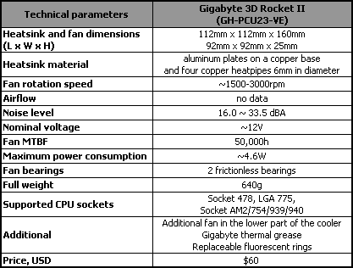
  - Appropriate materials for work

Best practices for choosing materials
To choose materials, you have to:
- Understand the critical components of your design. The first step in the process of choosing the right material is to understand which structural elements are most important for the mechanical integrity of your product.
- Know your materials.
- Validate your mechanical design

Self-Check-1

Directions: Answer all the questions listed below.

Part I: Say true or false (each 1 point)
- Personal protective equipment include those prescribed under legislation/ regulations/codes of practice and workplace policies and practices.
- Occupational safety and health cannot be important for moral, legal, and financial reasons.
- Effective OHS regulation requires that work unsafe provides clear, accessible advice and guidance.
Part II: Choose
- Which type of hazard including repetitive movements, improper set up of workstation, poor design of equipment, workstation design, (postural) or workflow, manual handling.
A. Ergonomic C. Physical
B. Psychological D. None
- Of the following which one is safety equipment?
A. dust mask C. goggle
B. work wear D. all
Part III: short answer
- Write best practice of selecting appropriate materials. (4 points)
- List the requirements of job. (3 points)
- Explain the difference between procedure and work instruction. (4 points)
- Define job specification? (2 points)
- What are the goals of OHS? (4 points)
- List at least four workplace hazards? (4 points)

Unit Two: MUDA and its problem
This unit to provide you the necessary information regarding the following content coverage and topics:
- Plan of MUDA
  - Visual Management Board/Kaizen Board
  - Tools and techniques to draw and analysesituation of the work place
  - Causes and effects of MUDA
  - Statistical tools and techniques /Kaizen elements
  - Relevant procedures for wastes/MUDA
This guide will also assist you to attain the learning outcomes stated in the cover page. Specifically, upon completion of this learning guide, you will be able to:
- Follow Visual Management Board/Kaizen Board.
- Use tools and techniques to draw and analyze, and prepare and implement problem identification.
- Discuss Causes and effects of MUDA.
- Identify and list all possible problems related to kaizen elements using statistical tools and techniques on work place.
- Identify and measure wastes/MUDA based on relevant procedures.
- Report the Identified and measured wastes to relevant personnel.

Plan of MUDA

Definition of MUDA
MUDA is a Japanese word meaning Wasteful Activity which use resources, time or cost without adding value.
In other words, it is anything unnecessary in operation that affects the quality of the product/service, productivity, delivery time and also production cost. MUDA can be eliminated immediately.

Types of MUDA
The most well-known category of wastes is the “seven deadly wastes,” which captures the essence of all the ideas discussed above and simplifies them to help you root out waste throughout your production process. You will need strongly motivated people with an instinct for seeing and removing waste. Identifying and eliminating these seven types of waste will forge the path to lean production.
- Overproduction- To produce things more than necessary in terms of type, time, and volume. It is called “the worst kind of Muda” since it hides all the other wastes.
- Inventory- The situation where items such as raw materials, work in process and finished goods are stagnant or which are not having value added to them. Some are located in the warehouses, and others are in-process inventory.
- Motion - These are non-value adding movements or more than necessary movements of workers, equipment, and machines, such as looking for goods, bending, stretching, walking, lifting, reaching etc.
- Conveyance/Transportation - It is unnecessary transportation of parts between processes caused by unnecessary transportation distance, temporary storage, and relocations or re-piling up. Transportation does not create any value added except for transportation companies. Transportation is usually difficult to be totally eliminated but reducing is possible.
- Waiting/ Idle time - Refers to both human and machine waiting.
This includes all kinds of waste of time such as workers or parts waiting:
- For an upstream process to deliver.
- For a machine to finish processing.
- For incoming parts or materials.
- For process that has a long wait time
- Defect making - This includes defects, inspections for defects in-process, and claims, rescheduling, and resource loss.
- Processing - This consists of processing and operations primarily unnecessary. It is processing beyond the standard required by the customer.

Concept of Planning
Planning is the most basic and primary function of management. It is the pre decided outline of the activities to be conducted in the organization. Planning is the process of deciding when, what, when where and how to do a certain activity before starting to work.

Visual Management Board/Kaizen Board

Definition
Kaizen Visual Management Boards are key visual communication tools that help teams and organizations work harder to manage their continuous improvement efforts. They will help you accelerate improvements, and make sure that all your ideas flow and progress from to do to done'.
Kaizen Visual Management Boards are key visual communication tools that help teams and organizations work harder to manage their continuous improvement efforts. They will help you accelerate improvements, and make sure that all your ideas flow and progress from to do to done’. Kaizen Visual management boards are widely used across various sectors including the healthcare and automotive industry, as a way of reducing waste and creating a more streamlined and agile supply chain.
Visual Management Boards are extremely popular in Organizations who are looking to pursue Lean & Continuous Improvement. Implementing Visual Management that works for your business will allow you to reduce visual clutter and establish performance standards for each job and process. Successfully implementing Visual Management will come with a number of benefits including:
- Improve Productivity – Keep your workforce organized and productive whilst reducing downtime.
- Impress Clients – Display to your Visitors that you’re invested in continuous improvement.
- Reduce Waste – Make waste reduction a daily concern through visual management.
- Promote Values – Enact your values and make them part of the culture of your working environment
- Raise Awareness – Ensure all your workforces are complying with your rules & regulations.

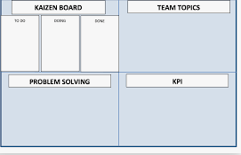
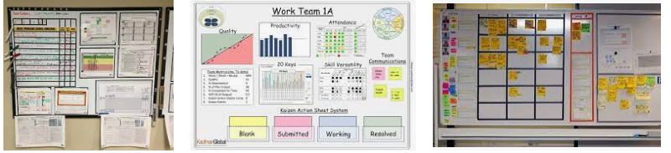
Figure 2.1. Visual Management Board/kaizen

Tools and techniques to draw and analyze situation of the work place

Definitions of work place
A workplace is a location where someone works for their employer, a place of employment. Such a place can range from a home office to a large office building or factory. For industrialized societies, the workplace is one of the most important social spaces other than the home, constituting "a central concept for several entities: the worker and his/her family, the employing organization, the customers of the organization, and the society as a whole”. The development of new communication technologies have led to the development of the virtual workplace, a workplace that is not located in any one physical space.

Plant Layout

Concept of Plant Layout
Plant layout is a plan for effective utilization of facilities for the manufacture of products; involving a most efficient and economical arrangement of machines, materials, personnel, storage space and all supporting services, within available floor space.

Types of Plant Layout
Two basic plans of the arrangement of manufacturing facilities are – product layout and process layout. The only other alternative is a combination of product and process layouts, in the same plant.
- Product Layout (or Line Layout)
In this type of layout, all the machines are arranged in the sequence, as required to produce a specific product. It is called line layout because machines are arrange in a straight line. The raw materials are fed at one end and taken out as finished product to the other end.
- Process Layout (or Functional Layout)
In this type of layout, all machines performing similar type of operations are grouped at one location i.e. all lathes, milling machines etc. are grouped in the shop and they will be clustered in like groups.
- Combination Layout
In practice, plants are rarely laid out either in product or process layout form. Generally a combination of the two basic layouts is employed; to derive the advantages of both systems of layout. For example, refrigerator manufacturing uses a combination layout.
Process layout is used to produce various operations like stamping, welding, heat treatment being carried out in different work centers as per requirement. The final assembly of the product is done in a product type layout.
- Fixed Position Layout
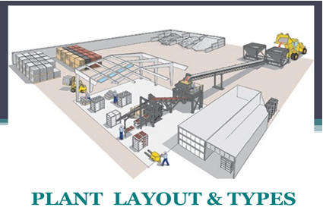
It is also called stationary layout. In this type of layout men, materials and machines are brought to a product that remains in one place owing to its size. Ship-building, air-craft manufacturing, wagon building, heavy construction of dams, bridges, buildings etc. are typical examples of such layout.

Figure 2.1. Plant layout

Process flow

Process flow diagram
A Process Flow Diagram (PFD) is a type of flowchart that illustrates the relationships between major components at an industrial plant. It's most often used in chemical engineering and process engineering, though its concepts are sometimes applied to other processes as well. It’s used to document a process, improve a process or model a new one. Depending on its use and content, it may also be called a Process Flow Chart, Flow sheet, Block Flow Diagram, Schematic Flow Diagram, Macro Flowchart, Top-down Flowchart, Piping and Instrument Diagram, System Flow Diagram or System Diagram. They use a series of symbols and notations to depict a process. The symbols vary in different places, and the diagrams may range from simple, hand-drawn scrawls or sticky notes to professional-looking diagrams with expandable detail, produced with software.

Process flow diagram symbols and elements
The most common PFD symbols in use today come from agencies such the International Organization for Standardization (ISO 10628 – Flow Diagrams for Process Plants, General Rules), the German Institute for Standardization (DIN) and the American National Standards Institute (ANSI.) However, many companies use their own symbols, which are often similar but vary as they become more detailed.
A typical PFD for a single unit process will include these elements:
- Major equipment: Including names and ID numbers. Examples include compressors, mixers, vessels, pumps, boilers and coolers.
- Process piping: Moves the product, usually fluids, between equipment pieces.
- Process flow direction
- Control valves and process-critical valves
- Major bypass and recirculation systems
- Operational data: Such as pressure, temperature, density, mass flow rate and mass-energy balance. Values often will include minimum, normal and maximum.
- Composition of fluids
- Process stream names
- Connections with other systems
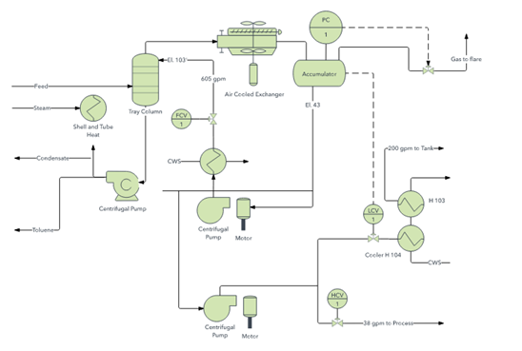
Figure 2.2. Process flow

Tools and Equipment for Waste/Muda Identification
To identify waste/Muda, the following tools and equipment are used.
  - Tape/Meter - is used to measure distances or lengths.
  - Stop watch - is used to measure operation/processing or waiting/idling times.
  - Photo Camera - may be necessary to take pictures, such as shop layout, for analysis.
  - Video Camera - may be necessary to record video of each work element to study and identify wastes, such as motion, processing, waiting, etc.
  - Calculator - required to make arithmetic calculations.

Causes and effects of MUDA

Causes of Muda of Overproduction
Some of the following are the causes of Muda of overproduction.
- Large-lot production
- Anticipatory production (producing product in advance of demand)
- Inability to achieve short changeover times with the large equipment used in mass production systems
- Creating enough stock to replace the number of defective parts produced
- Overstaffing or too much equipment
- Machines that turn out parts too quickly
Effects of MUDA of Overproduction
Companies often have overproduction as a result of large-lot manufacturing methods or mass production. There are several unfortunate effects of over production:
- Anticipatory buying of parts and materials
- Blocked flow of goods
- Increased inventory
- No flexibility in planning
- Occurrence of defects

Causes of MUDA of Inventory
Some of the following are the causes of MUDA of inventory.
- Acceptance of inventory as normal or as a “necessary evil”
- Poor equipment lay out
- Long changeover times
- Shish-kabob or large lot production
- Obstructed flow of goods
- Anticipatory production
- Defective parts
- Upstream process is too fast for the downstream process

Effects of MUDA of Inventory
- Waste of space
- Needs for inspection, and transportation
- Expansion of working fund
- Shelf life may expire
- It ties up cash
- Makes FIFO inventory management more difficult

Causes of MUDA of motion
- Isolated operations
- Low employee morale
- Poor work layout
- Lack of training
- Undeveloped skill

Effects of MUDA of motion
- Increase in manpower and processing
- Unstable operation
- Increases production time
- Can cause injury

Causes of MUDA of Conveyance/Transportation
- Poor layout
- Shish-skilled workers
- Sitting to perform operations
- The need for conveyance systems is assumed

Effects of Muda of Conveyance/Transportation
- Waste of space
- Production deterioration
- Expansion of transportation facilities
- Occurrence of scratches
- Increase production time and cost
- wastes time and energy

Causes of MUDA of Waiting/ Idle time
- Obstruction of flow
- Poor equipment layout
- Trouble at the upstream process
- Capacity imbalances
- Large Lot-production

Effects of MUDA of Waiting/ Idle time
- Waste of manpower, time, & machines
- Increase in the in-process inventory
- Failed delivery dates
- Poor workflow continuity

Causes of MUDA of Defect making
- Emphasis on downstream inspection
- No standard for inspection work
- Omission of standard operations
- Material handling and conveyance

Effects of Muda of Defect making
- Increase in material cost
- Productivity deterioration
- Increase in personnel & processes for inspection
- Increase in defects and claims
- Invite reworking costs

Causes of Muda of Processing
- Inadequate study of processes
- Inadequate study of operations
- Incomplete standardization
- Materials are not studied

Effects of Muda of Processing
- Unnecessary processes or operation
- Increase in manpower and man-hour
- Lower workability
- Increase in defects
- Can reduce life of components

Statistical tools and techniques /Kaizen elements

Seven basic QC Tools
- Cause and Effect Diagram
Cause and Effect Diagram is also known as Ishikawa Diagram and FishboneDiagram. It was developed by Kaoru Ishikawa in 1968.
- Used for identification of root-causes
- Key problem is represented as eyeof the fish
- Root-causes are represented asbones and sub-bones of the fish
- 5M represents - Man, Machine, Material, Method, Mother Nature
- 1P represent - people
- 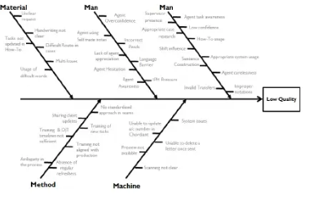
Figure 2.2. Cause and Effect Diagram / Fish bone diagram
- Check Sheets
Check Sheets is one of the simplest tool that helps us standardize activities. It can be used in any process and can be easily customized for use.
- Used for real time data collection
- A check sheet has marks as described in the figure
- The marks are divided in separate groups
- Mostly used to identify defects in a process
- Also used to standardize activities and as a reminder tool for effective planning

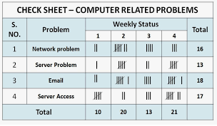
Figure 2.3. Check sheet

- Control Charts
Control Charts were developed by Walter A. Shewhart in 1920’s. It helps us to understand whether the process is in statistical control.
- Used to track the performance of the metric in focus (Y)
- UCL and LCL are +/- 3σ away from the mean
- When points fall outside control limits, process is not considered in statistical control
- Concepts of common cause and special cause variation are used
- Different control charts are used for different types of data
    - 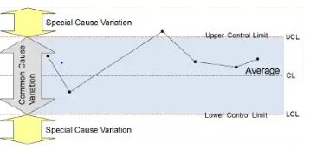
Figure 2.4.Control Charts
- Histogram
Histogram is also known as Frequency Plot. It was first developed by KarlPearson.
- Used to identify the probability distribution of continuous data
- Can only be used for continuous data
- Resembles bar chartbar chart is created from count datahistogram is create from frequency
- Histogram requires limited statistical knowledge
  - 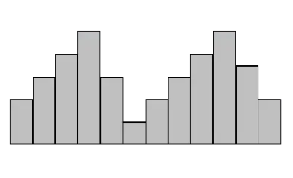
Figure 2.5. Histogram
- Pareto Charts
Pareto Charts were developed by Vilfredo Pareto. They are based on 80:20rule where 80% causes are due to 20% problems.
- Helps identify and quantify toproot-causes from trivial many
- Is used for discrete data
- Requires data collation (defects, errors, count data, etc.)
- Easy to understand graphical representation allows users to easily infer results
- Helps in immediate notification of the results
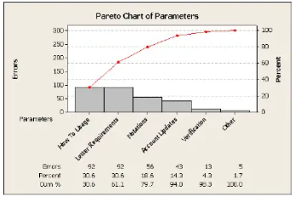
Figure 2.6.Pareto Charts
- Scatter Diagram
Scatter Diagram or Scatterplots were developed by Francis Galton to identify the relationship between two continuous variables.
- Helps understand the extent of relationship between two variables
- Is used for continuous data only
- Requires data collation (for both Xand Y variables)
- Easy to understand graphical representation allows users to easily infer results
- Data can be positively or negatively correlated. No correlation also exists

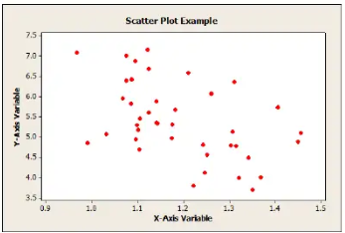
Figure 2.7. Scatter Diagram
- Stratification
Stratification is bifurcation of data into meaningful groups. Most widely used stratification tool is run chart.
- Helps understand whether data is stable?
- Is used for continuous data only
- Identifies if data has clusters, mixtures, trends or oscillations
- Resembles to a line chart
- Data is collected and plotted overtime (time scale is used as X-axis)
- Centre line is always the“median”of the data set
- 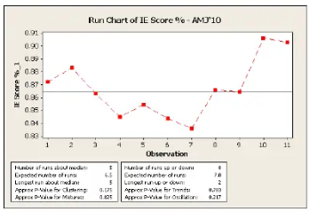
Figure 2.8.Stratification

Relevant procedures for wastes/MUDA Identification

Benefits of identifying MUDA
Cutting the hidden costs of production-It is estimated that 80 percent of production activities and associated costs are non-value-added, or waste. When factories begin to focus on identifying and eliminating waste, the impact on the bottom line is astronomical.
Increased customer satisfaction- Customer satisfaction rises as a direct result of implementing lean production. When waste is eliminated from production, deliveries occur on time and product quality goes up.
To Shop floor workers
Increased job satisfaction- No longer will you spend hours looking for missing tools, waiting for materials to arrive, walking around piles of inventory, lifting and setting down heavy parts or tools, working in unsafe conditions and all the other things you have to do that are not essential to your job. The frustrating non-value-added aspects of your job will disappear and what you are trained to do and enjoy doing will be the major part of how you spend your time.
Contributing to improvement- Your ideas about how to improve your job will be listened to and you will participate in taking the frustration out of the work place. Part of your job will be to find root causes and to create solutions that last. You will not have to make short-term fixes or live with someone else’s short-term fixes that no longer solves the problems you face.
There is no question that when production waste is rooted out everyone is happier. The flow of materials creates a hum in the workplace: a rhythm of the flow of materials from supplier to customer emerges as the value-added processes are freed up to operate at the rate of customer demand.

Plan and procedure for Waste/Muda Identification
It is not easy to find waste when you look at the production line or the warehouse or an operation. If you have never been involved in improvement activities you will find it even harder to discover waste that may be right in front of you. Waste is everywhere, in every operation; it is so common and you are so used to it that it is hard to see.
The steps to effective waste identification are:
- Make waste visible
- Be conscious of the waste
- Be accountable for the waste.
- Measure the waste.
    - Make waste visible:- Waste can be made visible in several ways such as:
- Shop layout analysis
- Process flow analysis
- Take photos/video
I. Shop layout analysis and Process flow analysis- There are several tools you can use to analyze current conditions of shop layout and process flow quickly and effectively.
- The Arrow Diagram:-focuses on the flow of goods to discover waste (Arrow diagrams have recently been renamed value stream maps). We include here a simple method for creating an arrow diagram to get a good understanding of your production process and to see where the waste exists in your workplace.
The factors to be identified in your arrow diagram are retention, conveyance, processing and inspection. There are specific symbols you use to indicate each of these aspects of a production process as indicated below

Table 2.1. Symbols used in Arrow Diagram
Analysis factors | Symbols | Description | Amount of waste
Retention |  | When the work-in-process flow is stopped (for other than conveyance, processing, or inspection) | Large
Conveyance |  | When the work-in-process is moved from one place to another | Large
Processing |  | When the work-in-process is changed physically or chemically for added value | There may be some waste in the process
Inspection |  | When goods are inspected for conformance to quality and dimensional standards | Large

Steps for creating your arrow diagram.
1. Understand the purpose - The purpose is to discover major forms of waste. The arrow diagram will help your improvement team “see” the waste.
2. Select the product to be analyzed- You can do a product/quantity (PQ) analysis to compare products and quantity. Choose products with a large output and those with many production problems as starting points for your analysis of current conditions using the arrow diagram.
3. Prepare a factory layout diagram- Include the entire factory layout, indicating the position of machines, worktables and other equipment. Store the original in a safe place so that you can make a copy of it each time you want to analyze another product line.
4. Make the arrow diagram- Do this on the factory floor. Use the symbols below to show the different types of activities that occur. The map will make the waste more obvious to you and your team than when you are simply standing on the factory floor observing standard operations. Connect the symbols with lines that show the direction of the flow and the sequence of product through each operation. Create other symbols as you need to. At all conveyance points, note the conveyance distance and type of conveyance. At all retention points, note average work-in-process inventory.
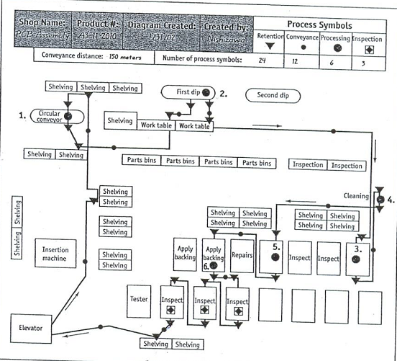

Figure 2.3. Arrow Diagram of a Painted Circuit board Assembly Shop

- Summary Chart of Flow Analysis: - Now that you have done an arrow diagram, write up a Summary Chart of Flow Analysis. Count the symbols you used on the arrow diagram to show totals for the number of retention and conveyance and inspection points. Also note the total amount of goods retained and the total conveyance distance. Keep track of changes after improvements are made using the same chart to compare. With these tools in hand, brainstorm improvement ideas. In brainstorming, you must let ideas flow freely. One unlikely suggestion may trigger a good idea. Select and further analyze good ideas. The arrow diagram and the flow analysis should not take you too long or keep you away from your observation of the factory floor. Draw the arrow diagram while watching the production of the product on the floor and use it to help you see the waste there. Keep it relevant and keep looking. The whole purpose of using this tool and the others discussed is to help you gain a “sixth sense” for waste. You will start to see the waste at some point as you do this, and when you do you will never be able to not see it again.

Table 2.2. Summary Chart of Flow Analysis
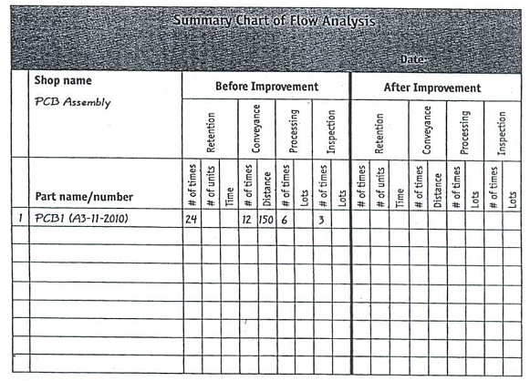

- The Operations Analysis Table:-The Operations Analysis Table focuses on people’s actions. As discussed in the previous topic, not everything you do adds value. Operations analysis tables help you identify the waste in your own operations. See the table below. Either have your supervisor fill in the table or do it as a team, filling it in for each other.

Table 2.3.Operation Analysis Table for an Aluminum Casting Deburring Operation

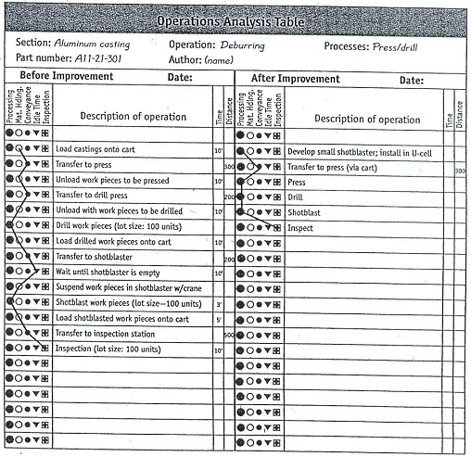

Steps
1. Fill in the table on the factory floor- It is important to look at the real situation as you fill in the table, even if you know the situation by heart. As you fill in the form, you will see things differently.
2. Look for detail – Write everything down that you possibly can.
3. Now identify the waste – Analyze as critically as you can to distinguish work from wasteful movement. Everything that is not value-added must be counted as waste.
4. Set an improvement goal – Review all the data from your observation and decide what would be best to improve and how much improvement you expect.
5. Eliminate waste- Eliminate waste from everything except the real work operations. Write down the results of your improvement efforts on the “After Improvement” side of the table.

- The Standard Operation Combination Chart:-Standard operations are a critical aspect of lean production. In order to create standard operations, current conditions must be understood and waste must be eliminated from all aspects of the process. A Standard Operation Combination Chart focuses on the relationship of people, goods and machines. By plotting the cycle time of all activities in the process you can discover where the waste is and design the process to create a more efficient combination and reduce overall cycle time. See the figure below for an example of a combination chart.

Table 2.4. Standard Operation Combination Chart for a Gear Cutting Process
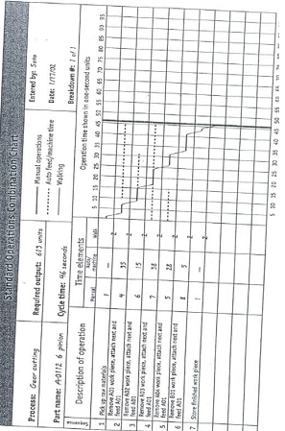

- The Workshop Checklist for Major Waste Finding:-In the previous portions you have seen detailed checklists for identifying specific instances of each one of the seven deadly wastes. The Workshop Checklist for Major Waste Finding allows you to identify – in a more general way – the seven types of waste in a work area. See the figure below. You might want to use this checklist before using the detailed checklists. Checklists are good tools for identifying waste and recording improvement ideas.

Table 2.5. Check list for major waste finding

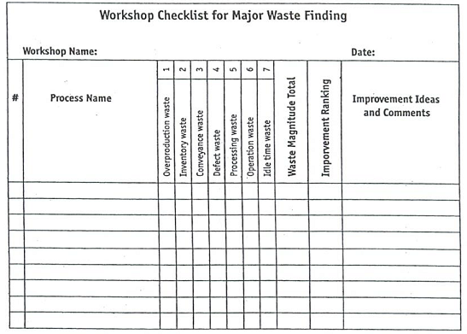

Steps
- Choose several processes or work areas and look for waste.
- Using the above figure find the major forms of waste at each process.
- Note the magnitude of each waste (Using the figure below).
- Rank the improvements that are needed. Focus improvements on the process with the greatest total when you add up the magnitude columns.

0----------No waste found

1---------Very little waste
Magnitude
of 2--------Some waste
Waste
3--------A lot of waste

Figure 2.4.Four Level of Magnitude

- Choose the first process to be improved from the workshop checklist.
- Using the more detailed waste-finding checklists provided, find more specific instances of waste
- Observe the types and magnitude of the detailed waste
- Brainstorm improvement ideas and then carry out them

II. Taking photos/Video: - Taking photos and videos and analyzing are also valuable techniques to find waste.
B. Be conscious of the waste: -When something is denied as waste, it also cannot be stopped.
C. Be accountable for the waste: -When one refuses to accept responsibility for the waste, then he/she will not eliminate it.
D. Measure the magnitude of the waste: -When the waste is not measured, people may think it is small or insignificant and therefore will not be motivated to stop it. What is not measured is not improved. Appreciate its size and magnitude.
- Do time study by work element
- Measure Travel distance
- Measure Total steps
- Make list of items/products, who produces them and who uses them & those in warehouses, storages etc.
Work element
The distinct steps required to complete one cycle at a workstation; the smallest increment of work that can be moved to another operator.
Breaking work into its elements helps to identify and eliminate waste that is hidden within an operator’s cycle. The elements can be distributed in relation to take time to create continuous flow. For instance, in the Operator Balance Chart illustration the small vertical boxes represent work elements.
Measure Travel distance
The 'travel distance' is measured by way of the shortest route which if: there is fixed seating or other fixed obstructions, is along the center line of the seat ways and gangways; it includes a stair, is along the pitch line on the Centre line of travel.
5S
5S is a workplace organization method that uses a list of five Japanese words: seiri,seiton,seisō,seiketsu and shitsuke. These have been translated as "sort", "set in order", "shine", "standardize" and "sustain".The list describes how to organize a work space for efficiency and effectiveness by identifying and storing the items used, maintaining the area and items, and sustaining the new order. The decision-making process usually comes from a dialogue about standardization, which builds understanding among employees of how they should do the work.
    - Layout improvement
The Challenge - Our client struggled with delivering on time. The layout and segmentation of the organization also made it difficult to identify bottlenecks or problems.
The Solution- We decided to implement a ‘cellularization plan’ so that all steps where completed in sequence in the same area. We created a central aisle through the plan, which allowed for visual management. We also created an overall plant layout plan to support future development of Lean product flow.
The Result Central aisle way implemented and visual management improved, Bottleneck management implemented to improve on time delivery, Creation of overall plant layout plan and Reduced lead time in the evaluation stage of the repair process are the of layout improvement.
To improve layout we use the follow technique
- Brainstorming is a group creativity technique by which efforts are made to find a conclusion for a specific problem by gathering a list of ideas spontaneously contributed by its members.
In other words, brainstorming is a situation where a group of people meet to generate new ideas and solutions around a specific domain of interest by removing inhibitions. People are able to think more freely and they suggest as many spontaneous new ideas as possible. All the ideas are noted down without criticism and after the brainstorming session the ideas are evaluated.
- Andon is a lean manufacturing term referring to a system that notifies management, maintenance, and other workers of a quality or process problem. Traditional Andon systems enable a machine or its operator to activate an alert (visual or audible) at a particular workstation.
- U-line:-U-shaped production line can be described as a special type of cellular manufacturing used in just-in-time (JIT) and Lean Manufacturing. Machines are arranged around a U-shaped line, in the order in which production operations are performed. Operators work inside the U-line. One operator supervises both the entrance and the exit of the line. In the U-line, tasks are organized into stations that can cross from one side of the line to the other. The assignment of tasks to stations on a U-line exploits the geometry of the line to keep the return and crossover distances as small as possible. Consequently, total travel distance and, hence, travel time is less on a U-line.
- Multi-process handling & Multi-skilled operators:-When a machine operator is doing tasks for multiple processes sequentially, and this is contributing the flow of material, it is called multi-process handling.
- Cell production line:-Cell production is a form of mass production that divides work into teams known as cells. Each cell is managed to achieve goals such as quality, efficiency and waste reduction.
- TPM (Total Productive Maintenance):- is started as a method of physical asset management focused on maintaining and improving manufacturing machinery, in order to reduce the operating cost to an organization. After the PM award was created and awarded to Nippon Denso in 1971, the JIPM (Japanese Institute of Plant Maintenance), expanded it to include 8 pillars of TPM that required involvement from all areas of manufacturing in the concepts of lean Manufacturing.
The eight pillars of TPM are mostly focused on proactive and preventive techniques for improving equipment reliability:
- Autonomous Maintenance - Operators who use all of their senses to help identify causes for losses
- Focused Improvement - Scientific approach to problem solving to eliminate losses from the factory
- Planned Maintenance - Professional maintenance activities performed by trained mechanics and engineers
- Quality management - Scientific and statistical approach to identifying defects and eliminating the cause of them
- Early/equipment management - Scientific introduction of equipment and design concepts that eliminate losses and make it easier to make defect free production efficiently.
- Education and Training - Support to continuous improvement of knowledge of all workers and management
- Administrative & office TPM - Using TPM tools to improve all the support aspects of a manufacturing plant including production scheduling, materials management and information flow, As well as increasing moral of individuals and offering awards to well deserving employees for increasing their morals.
- Safety Health Environmental condition's

Self-check-2
Directions: Answer all the questions listed below.
Part I: say true or false (each 1 point)
- Tape/Meteris of the tools to identify Muda/ wastes.
- Planning is the most basic and primary function of management.
- Overproduction is of the 7 types of Muda.
- Eliminating Muda decreases job satisfaction.
Part II: Choose (each 1 point
- Of the following which one is wastage?
A. overproduction C. motion E. all
B. defects D. over-processing
- Making waste visible during waste identification is through
A.Shop layout analysis
B. Process flow analysis
C. Take photos/video
D. all
3.Which one of the following is among the eight pillars of TPM?
A.Quality management
B. Planned Maintenance
C. Education and Training
D. all
4. Of the following one is quality control (QC) tool.
A.cause and effect diagram
B. Pareto charts
C. scatter diagram
D. all
E. none
Part III: Short answer
1. What are the seven deadly wastes/Muda? (7 points)
2. Write at least two causes and effects of each type of the seven deadly wastes/Muda. (10)
3.What are the benefits of identifying and eliminating wastes/Muda to a company? (4 points)
4. What are the benefits of identifying and eliminating wastes/Muda to the workers of a company? (4 points)
5. Write down the steps to identify wastes/Muda. (4 points)
6. List out at least three ways to make waste visible. (3 points)
7. What are the four factors to be identified in arrow diagram? (4 points)

Unit Three: Analyze causes of a problem
This unit to provide you the necessary information regarding the following content coverage and topics:
  - Possible causes of a problem
  - Cause relationships using 4M1E
  - The root cause of the problem
  - Creative idea generation toeliminate most critical root causes
  - Solutions for potential complications
  - Summaries of the action plan
This guide will also assist you to attain the learning outcomes stated in the cover page. Specifically, upon completion of this learning guide, you will be able to:
- Identify and list possible causes of a problem.
- Analyze cause relationships using 4M1E.
- Select the root cause which is most directly related to the problem.
- List all possible ways to eliminate the most critical root cause using creative idea generation.
- Evaluate the solutions for potential complications.
- Prepare detailed summaries of the action plan to implement the suggested solution.

Possible causes of a problem
Waste of defects can be caused by inefficiencies in manufacturing processes, unclear operating procedures, and poor quality raw materials from suppliers, or staff who are poorly trained in the use of machinery or tools.
Common causes of Inventory Waste include:
- Overproduction of goods
- Delays in production or 'waste of waiting'
- Inventory defects
- Excessive transportation

Cause relationships using 4M1E
The 4M is a method that allows to identify and group causes that impact to a specific effect. 4M categories (Material, Method, Machine, and Man) are often used in the Cause-Effect Diagram created by Kaoru Ishikawa.
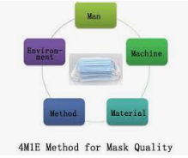
Figure 3.1. Showing 4M1E

Table 3.1. Cause and Effect Diagram with 4M1E
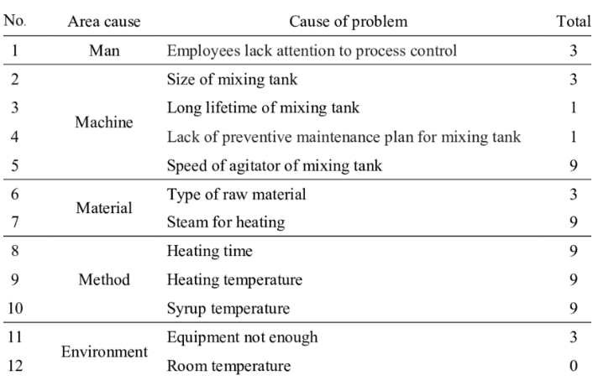

The root cause of the problem

Definition of root cause
Root causes are the basic reasons behind the problem or issue you are seeing in the community. Trying to figure out why the problem has developed is an essential part of the "problem solving process" in order to guarantee the right responses and also to help citizens "own" the problems.
What is the "but why?" technique?
The "But why?" technique is one method used to identify underlying causes of a community issue. These underlying factors are called "root causes."
The "But why?" technique examines a problem by asking questions to find out what caused it. Each time an answer is given, a follow-up "But why?" is asked.
For example, if you say that too many people in poor communities have problems with alcoholism, you should ask yourself "but why?" Once you come up with an answer to that question, probe the answer with another "but why?" question, until you reach the root of the problem, the root cause.
Identify root causes
Identifying genuine solutions to a problem means knowing what the real causes of the problem are. Taking action without identifying what factors contribute to the problem can result in misdirected efforts, and that wastes time and resources. However, by thoroughly studying the cause of the problem, you can build ownership, that is, by experiencing the problem you will understand it better, and be motivated to deal with it.
The "But why?" technique can be used to discover basic or "root" causes either in individuals or broader social systems:
It can be used to find which individual factors could provide targets of change for your cause, such as levels of knowledge, awareness, attitudes, and behavior.
Do people need more knowledge about nutrition?
Do children need to learn refusal skills to avoid smoking?
Do teenagers need to learn how to use contraceptives?
It can explore social causes. For example, it could help us determine why a certain neighborhood seems to have a higher rate of a specific problem. These social causes divide into three main sub-groups:
Cultural factors, such as customs, beliefs, and values;
Economic factors, such as money, land, and resources;
Political factors, such as decision-making power.
It can uncover multiple solutions for a certain problem and allow the user to see alternatives that he or she might not have seen before. It increases the chances of choosing the right solution, because many aspects of the problem are explored during the "But why?" exercise.
Whenever you are faced with addressing a challenging community problem. Of course, the "But why?" technique is not always your best bet and should not be used 100% of the time. It's extremely efficient to find a variety of solutions and is a quick and inexpensive technique that can be done by anyone, at anytime, anywhere. For some issues, however, you should use more sophisticated methods, such as surveys, interviews and data collecting.
When there is support for a "solution" that does not seem to get at the real causes of the problem. For example, if there is hunger in community, let's distribute free turkey at Thanksgiving.
When there is ignorance or denial of why a community problem exists.
Technique work
Here's how it works. A group examines a community problem by asking what caused it. Each time someone gives an answer, the "asker" continues to probe, mostly by asking "But why?" or "How could that have been prevented.
First, invite people who are both affected by the problem and are in a position to contribute to the solution to brainstorm possible causes. The more representative the working group is, the more likely it is for the root causes to be uncovered.
The working group should then examine a community problem, such as substance use or violence, by asking what caused it.
The "But why?" analysis leads to at least two very different conclusions. The criterion for choice between them is to look into the environment of each one. Many solutions may apply to your problem, so it's up to you to find the one that fits it better. The "But why?" analysis by itself doesn't lead automatically to the best solution.

Creative idea generation to eliminate most critical root causes

Definition of idea generation
Idea generation is defined as the process of creating, developing and communicating abstract, concrete, or visual concepts. To put it simply, it’s the process that requires finding new solutions for practical problems in all fields of life and work.

Elements of creative idea generation
All you need are the four essential elements of Creativity.
- Focus
- People
- Tools and
- Time

Idea generation methods
The 5W+H Method
Although it may seem like a random set of numbers at first glance, the 5W+H method is a really meaningful way to cope with the creative drought. The technique represents basic questions you need to ask when thinking about a specific topic: Who, what, where, when, why, and how?
Jason Richardson, a content creator at essay papers, shared his thoughts with us: “If you answer each of the 5W+H questions precisely – regardless of the topic – you can get one step closer to solving your problem. These answers should stimulate your brain to rethink the whole subject and find a new angle of looking at things.”
Social Listening
Idea generation doesn’t mean you have to come up with a great suggestion single-handedly. On the contrary, sometimes it’s enough to do a little bit of social listening and see what the target audience has to say about a certain topic. You can use social networks like Facebook or Twitter to find precious ideas coming from end-users.
Besides that, you can always organize an opinion poll to directly ask people what they want. For example, a platform such as Survey Monkey allows you to launch a simple survey within minutes, so why not use it as the idea generation tool?
Brainstorming
Brainstorming is a well-known method that people all over the world use for decades already. What makes this tactic so popular? Well, it’s the fact that no one gets laughed at for proposing a stupid idea. There is no right or wrong here – you just need to say the first thing that comes to your mind and that’s it. After a quick brainstorming session, you just need to filter through all suggestions and find the ones that have the biggest potential to succeed.
Role Playing
Walking in someone else’s shoes is everything but easy, but sometimes it’s the only way to break the barrier and think of a brilliant idea. The process is simple: you just need to switch places with your colleagues and try to embrace their point of view. It doesn’t guarantee immediate results, but it often leads to interesting conclusions and brand new ideas.
Use Online Tools
The Internet is filled with interesting tools that can assist you in identifying alternative ideas. You can choose between many different options, but the final decision usually depends on the nature and peculiarities of your business. However, we can definitely recommend a couple of valuable platforms here:
- Ever note: Nothing hurts like coming up with amazing solutions and forgetting it along the way. Ever note prevents this because it allows you to write down every thought instantly.
- Ninja Essays: It’s a team of incredibly creative authors who can help you to brainstorm and craft high-quality topics for your websites, blogs, or research papers.
Mind Mapping
Mind mapping is another method to get through the creative drought successfully. By definition, a mind map is a diagram for representing tasks, words, concepts, or items linked to and arranged around a central concept or subject using a non-linear graphical layout that allows the user to build an intuitive framework around a central concept.
Let’s say you are writing a screenplay. In this case, you can put the main character in the center of the map and then add links leading to all other elements of your movie – from plot and love relationships to supporting roles.
Thinking Reverse
The last solution on our list is very amusing. Instead of thinking about how to reach your goal, you can think about how not to achieve it. For example, you can make a plan on how to reduce the number of Instagram followers instead of increasing it. The so-called negative thinking often leads people to unbelievable conclusions, which in turn brings them a bunch of new ideas.

Summaries of the Action Plan
In summary, then, action planning is the process in which you plan what will happen in the project or organization in a given period of time, and clarify what resources are needed to make it possible. Before you can begin the action planning process, certain things need to be in place.

Concepts of Action Plan
In project management, an action plan is a document that lists the action steps needed to achieve project goals and objectives. Therefore, an action plan clarifies what resources you’ll need to reach those goals, makes a timeline for the tasks or action items and determines what team members you’ll need to do it all. We’ll define what project goals, project objectives, action items and action steps are later on in this guide.
An action plan documents the execution of the project plan. That is, it’s a detailed list of the work that must be done to complete the project goals, including the action steps that are involved in getting from the start of the project to the finish. An action plan is similar to a project implementation plan and it’s very helpful during the project planning and project execution phases.
Not only are you figuring out the action steps and timeline, but you’ll also determine who you’ll assemble for your project team to work on those tasks.

Writing an Action Plan
When someone prepares an action plan for Muda identification, the following things have to be considered:
- Define your Goals
There’s a difference between project goals and project objectives. Project goals refer to the high-level goals that the project will achieve. Those generally align with the strategic planning and business objectives of organizations.
- Define your Objectives
The project objectives are much more specific than the project goals. Project objectives refer to the deliverables and milestones that need to be completed to achieve your project goals.
- Define Action Steps
The action steps are a group of related tasks or action items that must be executed to produce project deliverables.
- Identify and Prioritize Action Items
Action items are small, individual tasks that make up the action steps that are outlined in your action plan. First, you need to identify task dependencies among them, and then assign those action items a priority level so that they’re executed sequentially.
- Define Roles & Responsibilities
Now that you’ve divided the work required to accomplish your action plan, you’ll need to assign action items to your project team members and define their roles and responsibilities.
- Allocate Resources
As with your project plan, your action plan has resource requirements. Having identified your action steps and action items will help you understand what resources are needed for each task and allocate them accordingly.

- Set SMART Goals
Your action plan needs to be monitored and controlled to measure its performance. That’s why it’s important that you set SMART goals for your action items, action steps and your project objectives. SMART goals stand for specific, measurable, attainable, relevant and timely.
- Set a Timeline for your Action Plan
As a project manager you’ll need to do your best to estimate how long it’ll take to complete your action items and action steps. Once you do so, you’ll have a timeline. You can use project management techniques like PERT charts or the critical path method to better estimate the duration of your project action plan.
- Write an Action Plan Template
Create or use a simple action plan template to collect tasks, deadlines and assignments. This is the place where everything task-related goes in your project action plan, so you have a place for all this crucial information.
Writing an action plan template it’s a great idea because you’ll need to use that format throughout the project. That’s why we’ve created a free action plan template that you can download.
- Use a Project Management Tool
Use a project management tool to keep you on task. Project Manager has project planning features that help you monitor and report on project progress and performance. Get a high-level view of the action plan with our live dashboards. Unlike other tools, we don’t make you set up the dashboard.
Self-check-3
Directions: Answer all the questions listed below.
Part I: Say True or False
1.The 4M is a method that allows to identify and group causes that impact to a specific effect.
2.Idea generation is the process of creating, developing and communicating abstract, concrete, or visual concepts.
3.Setting SMART Goal is necessary for writing an action plan.
Part II: Choose
1. Of the following which one is a common causes of Inventory Waste?
      - Overproduction of goods
      - Delays in production or 'waste of waiting'
      - Inventory defects
      - Excessive transportation
      - all
2. Waste of defects can be caused by
A. inefficiencies in manufacturing processes
B. unclear operating procedures
C. poor quality raw materials from suppliers
D. all
E. none
3. Among the following which one is an element of creativity?
A. Focus
B. People
C. Tools
D. Time
4. From the following which one is not a method for idea generation?
A. brainstorming B. mind mapping C. social listening D. all E. none

Part III: short answer
1. What are the elements of creativity? (4 points)
  - How to write an action plan?(4 points)
  - What is creative idea generation mean? (2 points)

Unit Four: Eliminate MUDA and Assess effectiveness of the solution
This unit to provide you the necessary information regarding the following content coverage and topics:
  - Plan of MUDA elimination by medium KPT members
  - Tools and techniques to eliminate wastes/MUDA
  - Tangible and intangible results
  - Compare tangible results
  - Report improvements
This guide will also assist you to attain the learning outcomes stated in the cover page. Specifically, upon completion of this learning guide, you will be able to:
  - .Prepare and implement Plan of MUDA elimination by medium KPT members.
  - Adopt necessary attitude and the ten basic principles for improvement to eliminate waste/MUDA.
  - Use tools and techniques to eliminate wastes/MUDA.
  - Reduce and eliminate Wastes/MUDA.
  - Identify tangible and intangible results.
  - Compare tangible results using various types of diagrams.
  - Report improvements gained by elimination of waste/MUDA.

Plan of MUDA elimination by medium KPT members

Muda elimination
Muda translates roughly as waste, and refers to the inefficiencies within processes which you can seek to reduce or eliminate entirely. In effect, lean declares war on waste – any waste. Waste or Muda is anything that does not have value or does not add value. Waste is something the customer will not pay for.

Ways to reduce waste
The 7 forms of waste is a concept that is an integral part of Lean management. Learn what costs you money and resources as well as how to eliminate waste from your work processes.
    - Identify the Key Areas of Waste
Anything that provides no value to the customer and contributes nothing to your bottom line but has a cost can be classified as waste. It may exist in every department of your company. Thus it’s critical for you to find out the most common areas of waste in your business.
Have you been producing too many goods that your customers do not even need? Or is there too much delay in your production process, so you need more time and costs to spend on machines and workers?
    - Manage Inventory Efficiently
Efficient inventory management means keeping the proper inventory (including raw materials, WIP, and finished goods), thereby reducing the risk of loss, decay, and damage. So, how do you control the procurement of goods at a manufacturing plant?
First of all, you must be able to forecast your inventory needs. Then, you need to make sure that the amounts and types of materials you keep are adequate for your production. Also, the goods you will produce follow your customer demands. This step aims to make sure that there will be no more unnecessary purchases.
    - Reduce Packaging Materials Usage
Product packaging is one of the significant contributors to waste. Good packaging designs are sometimes needed to highlight the uniqueness of your product, but that does not mean you have to sacrifice a lot of money for them.
Redesign your product if that’s possible. For example, replace your product packaging with reusable and recyclable materials for starting a zero-waste lifestyle. Also, consider ​​making a new product out of the cardboard boxes or leftover plastics that you use to pack your current products.
    - Establish Routine Maintenance Schedules
Check the condition of your machines and equipment regularly. Equipment damage or failures lead to unplanned downtime in the production process and other activities on the shop floor, which then cause order fulfilment delays. Furthermore, you will end up spending more on new machines and equipment. Therefore, it’s important to schedule regular preventive maintenance.
HashMicro’s Manufacturing System can make it easy for you to record conditions and schedule routine maintenance for all manufacturing assets. The system also allows you to monitor fuel consumption and track your truck’s location to identify problems early.
    - Leverage Automation for Your Business
You may be thinking that investing in software is not the right solution to reduce waste since you will still need to spend quite a lot of money to implement it. However, the cost you will spend on software is much cheaper than the costs you have to pay regularly on your workers, new machines, reparations, and other unnecessary tools.

Tools and techniques to eliminate wastes/MUDA

Adopting the Necessary Attitude
First you must adopt an attitude that supports your ability to see waste. Waste is hard enough to find when you want to find it; if you don’t want to find it, or if your response to find it is denial or resistance, then it will never be possible for you to root out waste and make your work environment stress free.
It is very important that you understand that one purpose of discovering waste is to take the frustration out of your work.
Many people will resist seeing the waste in their work. Just don’t let it be you. You may hear yourself or others saying things like: “Let’s not fix what is not broken.” “Can’t we live well enough alone?” “This is just another attempt to make us work harder for the same amount of money.” “It looks good on paper, but it will never work on the floor.” “We tried that twenty years ago. It didn’t work then; it won’t work now.” “That is not my job.” And so on.
You know the lines. You have probably said one or two of them at one time or another. We all have. Resistance is normal. Just don’t let it keep you from learning to see the waste in your work. In the end, you are the one who suffers most from the results of waste.

The Ten Basic Principles for Improvement
- Throw out all of your fixed ideas about how to do things.
- Think of how the new method will work-not how it will not.
- Don’t accept excuses. Totally deny the status quo.
- Don’t seek perfection. A 50 percent implementation rate is fine as long as it is done on the spot.
- Correct mistakes the moment they are found.
- Don’t spend a lot of money on improvements.
- Problems give you a chance to use your brain.
- Ask “Why?” at least five times until you find the ultimate cause.
- Ten people’s ideas are better than one person’.
- Improvement knows no limit.

Elimination of the seven types of Wastes/Muda
      - Eliminating Overproduction Wastes
In order to balance capacity and load without overproducing, you must implement the advanced methods of lean production:
- Full work
- Line balancing
- Pull production using kanban.
- Quick-changeover operations.
- Level production - small-lot, mixed production.
      - Eliminating Inventory Wastes
- U-shaped manufacturing cells, layout of equipment by process instead of operation.
- Production leveling
- Regulating the flow of production
- Pull production using kanban
- Quick changeover operations
      - Eliminating Motion Wastes
- Gradually switch to flow production
- Create U-shaped cell layout of equipment
- Make standardization through
- Increase training
- Increase operator awareness about motion during an operation
Where as many kinds of movement may be unnecessary, work is the movement you do to add value to the product. Movement that does not add value is waste. Find ways to reduce the amount of movement to do your value added work. Start by looking at the movement of your feet, then your hips, shoulders, arms, hands and fingers.
      - Eliminating Conveyance/Transportation Wastes
Basically, conveyance waste is corrected by redesigning equipment layout to create a flow between operations. Then you will be able to take out much of the complexity in the conveyance system and decrease material handling to a minimum. Some of the lean production methods that address conveyance flow:
- U-shaped manufacturing cells
- Flow production
- Multi skill workers
- Standing to perform operations
- Higher utilization rate
- Water beetles (material handlers in the kanban system of pull production)
    - Eliminating Waiting/Idle Time Wastes
- Production leveling
- Product-specific layout
- Mistake-proofing
- Human automation
- Quick changeover
- Autonomous maintenance
- Line balancing
    - Eliminating Defect Wastes
- Standard operations
- Mistake-proofing devices
- Full-lot inspection
- Building quality in at each process
- Flow production
- Elimination of the need to pick up and set down work pieces
- Improvement of jigs using human automation
- Promotion of value analysis and value engineering
To reduce defects, their root cause must be found. Inspection that only sorts out the defective parts is not a solution to defective waste; it is actually one of the major defect-related wastes. Until you initiate back-to-the-source inspection and build quality into every process through standardization, the effects of defects will continue to disrupt the flow of goods and decrease productivity.
    - Eliminating Processing Wastes
- More appropriate process design
- Review of operations
- Improvement of jigs using automation
- Thorough standardization
- Promotion of value analysis(VA) and value engineering(VE) techniques

Report improvements

Definition of reporting
Reporting means relating to the issuing of reports. A reporting entity is an organization or company, or group of companies that prepares financial reports. Reporting means relating to the issuing of reports.

Purpose of reporting
Reports communicate information which has been compiled as a result of research and analysis of data and of issues. Reports can cover a wide range of topics, but usually focus on transmitting information with a clear purpose, to a specific audience.

Types of report
There are different types of reports. Among those the following are listed below.
- Formal or Informal Reports
- Short or Long Reports
- Informational or Analytical Reports
- Proposal Report
- Vertical or Lateral Reports
- Internal or External Reports
- Periodic Reports

Good report
Structure material in a logical and coherent order; present your report in a consistent manner according to the instructions of the report brief; make appropriate conclusions that are supported by the evidence and analysis of the report; make thoughtful and practical recommendations where required.

Characteristics of Good or Essential report
- Suitable Title
- Simple
- Promptness
- Comparability
- Consistency.
- Precise and Accurate
- Relevant Information
- Presented to Required Person or Group or Department

Self-check-4
Directions: Answer all the questions listed below.
Part I: Say True or False
  - Muda is anything that does not have value or does not add value.
  - A reporting entity is an organization or company, or group of companies that prepares financial reports.
  - Periodic report is one of the types of report.
Part II: Choose
    - Of the following which one is the way to reduce wastes?
A .manage inventory efficiency
B. reduce packaging material usage
C. leverage automation
D. all
E. none
2. Which one isnot Characteristics of Good or Essential Report?
A.Suitable Title C.Promptness E. none
B. Simple D. all
3. How can you Eliminating Inventory Wastes?
A.byProduction leveling B.By Pull production using kanban

C. By regulating the flow of production D. By quick changeover operations

E. all
Part III: Short Answer
1. List down the type of report? (4 points)
2. Write at least two methods how to eliminate each of the seven deadly wastes. (5 points)
3. What are the characteristics of essential report? (5 points)

Unit Five: Prevent occurrence of wastes and sustain operation
This unit to provide you the necessary information regarding the following content coverage and topics:
  - Plan of MUDA prevention
  - Standards required for machines
  - Prevent occurrences of wastes/MUDA
  - Create waste-free workplace
  - Updating standard procedures and practices
  - Build capability of the work team
This guide will also assist you to attain the learning outcomes stated in the cover page. Specifically, upon completion of this learning guide, you will be able to:
- Prepare and implement Plan of MUDA prevention.
- Discuss and prepare Standards required for machines.
  - Prevent occurrences of wastes/MUDA using visual and auditory control methods.
  - Create waste-free workplace using 5W and 1H sheet.
  - Do the completion of required operation.
  - Facilitate the updating of standard procedures and practices.
  - Ensure and traineethe capability of the work team on the new SOPs.

Plan of MUDA prevention
We have discussed how you discover waste and what to do to remove it; but it doesn’t end there. Unfortunately, problems always crop up, and we prevent them from becoming sources of waste we will be right back where we started in no time at all. That is one reason why one of the very first things mentioned about discovering waste adopting the right attitude. If everyone is paying attention to keeping waste from taking hold, then you have a good chance of sustaining production flow. There are four important methods you can use for maintaining a waste-free production environment.
      - Standardization
The primary purpose of standardization is to create and sustain a waste-free process. Standardization means establishing standard procedures for every operation so that anyone can understand and use them – and everyone does. There are many aspects to standardization. Standards must be created, documented, well-communicated, adhered to, and regularly re-assessed.
Standards are required for:
- Machines
- Operations
- Defining normal and abnormal conditions
- Clerical procedures
- Procurement
      - Visual and Auditory Controls
One way waste enters into operations is when standards are not improved to meet changing conditions. Even standardization fails to sustain waste-free production if not systematically updated to take advantage of new materials, new technology, and worker improvement ideas. If the slightest defect occurs, the standard must be reconsidered.
The factory is a living thing and must constantly be adjusted to stay responsive to changes in the environment. Responsiveness must be systematic so that problems are addressed without losing the solid foundation of the waste-removing methods already established. The best way to do this is through visual and auditory controls.
Red-tagging – You probably did this at the beginning of your improvement activities when you implemented 5S. If not, do it now: put a red tag on everything in the factory that is not necessary to the current operations of the production process. Aftereveryone has had time to notice red-tagged items and claim any that are needed in their area, remove the remaining red-tagged items from the environment. Management can decide what to do with them: they can be sold, thrown out, or moved to a location where they are needed. Always keep the production floor free of any thing that is not directly part of the production process.
Signboards- The purpose of workstations and the names of the workers who operate them should be displayed at every processing point. Signboards can also identify equipment and processes so that everyone knows what things are and what they are used for. Standard quantities should be included on supply bins or carts. The products produced on each line or in each cell can be displayed, and so on.
Outlining- Boarders around tools and equipment, big and small, help people find and return things. Outlining can also create patterns of work-flow by using the floor to indicate where and where not to place things, where to walk, safety zones and danger zones. Outlining to indicate goods to be processed or parts that have been processed becomes a signal to material handlers for replenishing or for delivery to the next process.
Andon- Different colored lights can report the status and needs of a system and signal when defects or abnormal conditions occur so that problems can be solved immediately.
Kanban- These little signs accompany work-in-process. They are the flexible production instructions or work orders that trigger materials supply and production in a pull system, the hallmark of lean manufacturing.
Pitch and Inspection Buzzers- These indicate when operations get out of sync with demand or when defects are around. They keep awareness focused on solving problems and keep waste from taking root.
      - The 5W and 1H Sheet
The 5W and 1H (five “whys” and one “how”) is a powerful method and one that never stops being wasteful in sustaining a waste-free production environment. The 5W and 1H sheet is a tool that will help you systematically apply this method.
Figure 5.1 shows one sheet filled out. (Use the side columns when multiple questions or answers arise at any step of solving a single problem).
Figure 5.2 shows an example of an improvement idea that resulted from the use of the 5W1H Sheet in figure 5.1.

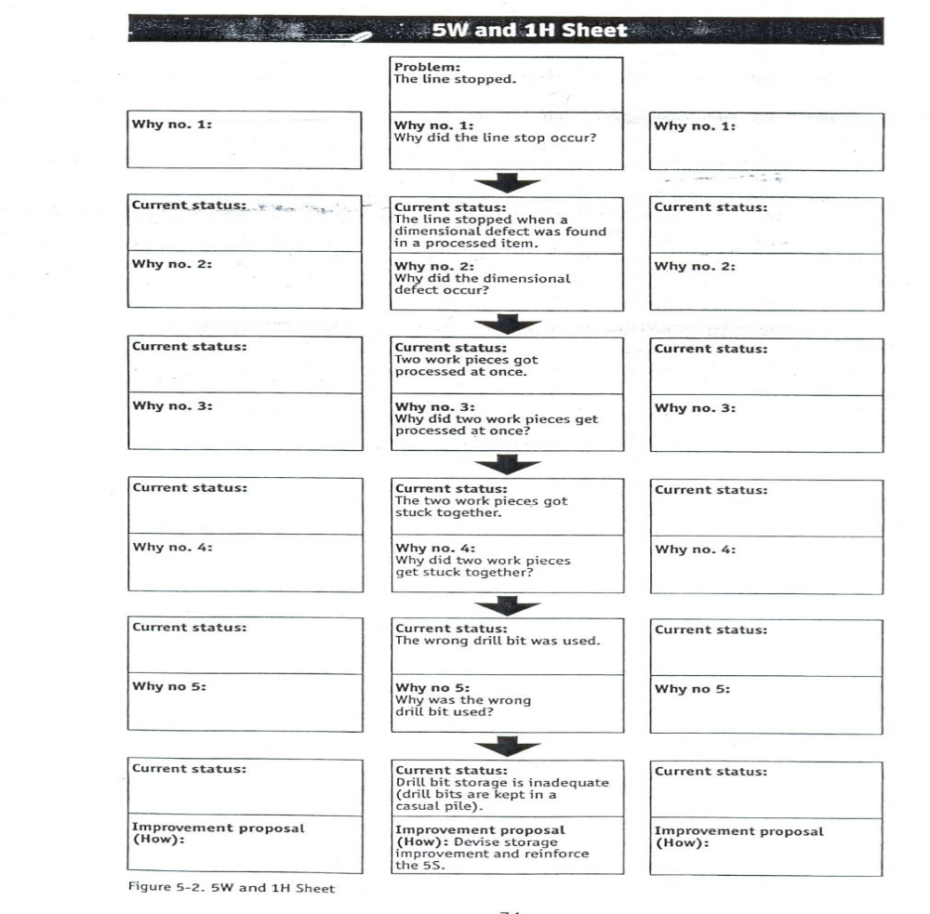
Figure 5.1. The 5W and 1H Sheet

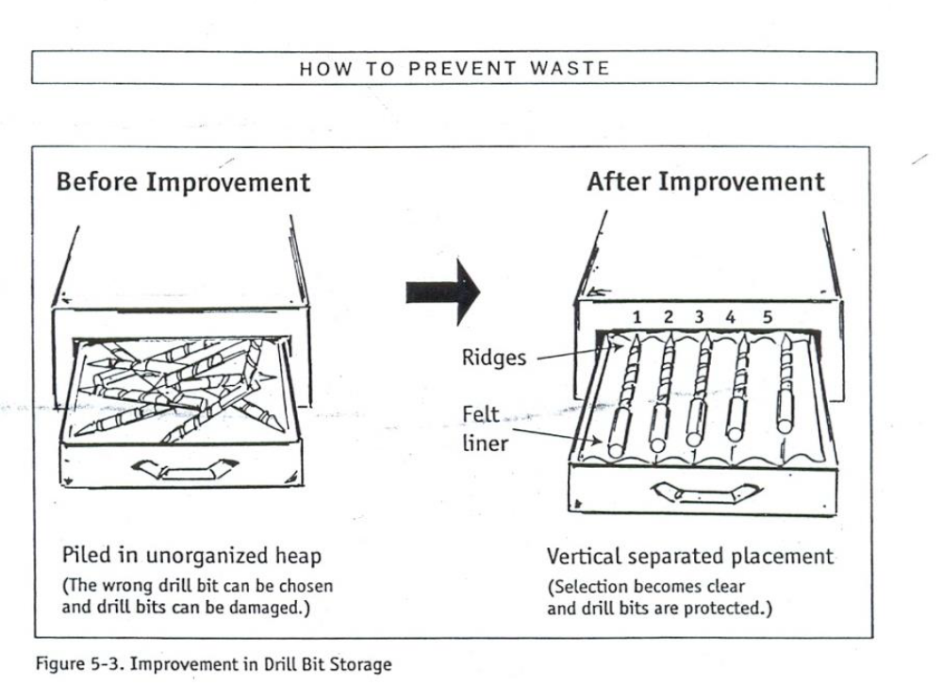
Figure 5.2. Showing Improvement in Drill Bit Storage

1 Five Key Concepts for Asking “Why” and “How”
Following these principles suggested by Hiroyuki Hirano when you are asking the 5”whys” and 1”how”:
- Look with the eyes of a child- All improvement begins with the first why. Never cease looking and never cease asking that first why. As you practice this, the result will follow.
- Remember three essentials for fact finding- (1) Go to where the problem occurred. (2) See the problem first-hand. (3) Confirm the facts based on your own observations.
- Be a walker and an observer- Supervisors and managers must continually work through the factory to see that standards are being followed and to practice seeing waste. Operators need to continually examine their own operations to stay alert for new problems and new ideas for solving them that may come to mind as they do their jobs.
- Break down fixed thinking- If you ask “why” and “how” often enough you will eventually run out of “known” answers. At this point you may reach internal mental resistance to the discovery of what you don’t know. Get in the habit of asking why and how beyond this point of fixed thinking. That is when you will make the big discoveries about waste and how to solve it.
- Do it now- Don’t wait. Put your ideas into practice immediately

Standards required for machines

Total Productive Maintenance (TPM)
It can be Total Productive Maintenance (TPM) is a maintenance program which involves a newly defined concept for maintaining plants and equipment. The goal of the TPM program is to markedly increase production while, at the same time, increasing employee morale and job satisfaction.
TPM brings maintenance into focus as a necessary and vitally important part of the business. It is no longer regarded as a non-profit activity. Down time for maintenance is scheduled as a part of the manufacturing day and, in some cases, as an integral part of the manufacturing process. The goal is to hold emergency and unscheduled maintenance to a minimum.
TPM
TPM was introduced to achieve the following objectives. The important ones are listed below.
- Avoid wastage in a quickly changing economic environment.
- Producing goods without reducing product quality.
- Reduce cost.
- Produce a low batch quantity at the earliest possible time.
- Goods send to the customers must be non-defective.

TPM Targets
- Productivity
- Obtain Minimum 80% OPE (Overall Plant Efficiency)
- Obtain Minimum 90% OEE (Overall Equipment Effectiveness)
- Run the machines even during lunch. (Lunch is for operators and not for machines!)
- Quality - Operate in a manner, so that there are no customer complaints
- .Cost - Reduce the manufacturing cost by 30%.
- Delivery time - Achieve 100% success in delivering the goods as required by the customer.
- Safety - Maintain accident free environment.
- Moral - Increase the suggestions by 3 times. Develop Multi-skilled and flexible workers.

The 8 Pillars of TPM

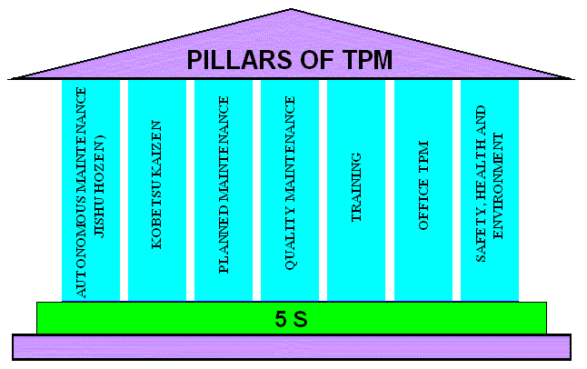
Figure 5.3. Pillars of TPM

Factors affecting equipment effectiveness
Factors affecting equipment effectiveness are:
- Equipment failure (breakdown)
- Setup and adjustment downtime
- Idling and minor stoppages
- Reduced speed
- Process defects
- Reduced yield

Cycle Time and Set-Up Reduction
The amount of time that elapses between the completions of two parts completed on the same line. Cycle time may also be defined as the amount of time it takes for a single operation to complete a single part. Both working definitions are based on shop floor observation. The general term “Cycle Time” should be specified as “Observed Cycle Time”. It is important to note that with all variations of “Cycle Time” definitions, the starting and ending point of each cycle must be exactly the same point to ensure a complete cycle.
Shorter runs produce customer orders with less lead time. However, equipment breakdowns, idling and minor stoppages will make it very difficult to reduce cycle times. Hence, cycle time reductions result in shorter and more frequent production runs. Suddenly, set-ups and adjustments become crucial in reducing cycle times. Past OEE (Overall Equipment Efficiency) studies show that set-up and adjustments can consume up to 50% of total production time.

5.2.4. The Equipment Losses
Equipment Availability | Set up and adjustments including:  - Changeovers  - Programming  - Test runs  Equipment Failures:  - Sporadic breakdowns  - Chronic breakdowns.
Equipment Efficiency | - Idling and Minor Stoppages  - Jams and other short stoppages.  - No parts, no operator.  - “Blocked”.  - Reduced Speed  - Equipment worn out.  - Lack of accuracy.
Quality | Process defects  - Scrap  - Rework
Others | - Equipment warm up  - No parts, no operator

Availability
Loading time = Total available time per day (or month) – Planned downtime
Planned downtime: amount of downtime officially scheduled in the production plan.

OEE (Overall Equipment Efficiency):
OEE = A x PE x Q
Possibly there are three ways that failure may occur.
A - Availability of the machine. Availability is proportion of time machine is actually available out of time it should be available. (The equipment can stop working completely known as a total failure),

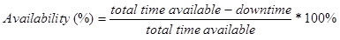

The equipment can work slower than it is capable of known as the partial failure (throughput rate/Performance), and

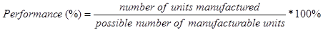

The equipment or product can lose quality known as quality failure (Quality).
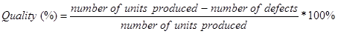

OEE Exercise
Calculate Availability, Performance, Quality and OEE based on the following information.
Item | Data
Shift Length | 8 hrs = 480 min
Short Breaks | 2@15 min = 30 min
Meal Breaks | 1@30min=30min
Down Time | 47min
Ideal Run Time | 60 pieces per min
Total Pieces | 19,271 pieces
Reject Pieces | 423 pieces
Table 5.1. TPM targets
Motives of TPM | - Adoption of life cycle approach for improving the overall performance of production equipment.  - Improving productivity by highly motivated workers which is achieved by job enlargement.  - The use of voluntary small group activities for identifying the cause of failure, possible plant and equipment modifications.
Uniqueness of TPM | The major difference between TPM and other concepts is that the operators are also made to involve in the maintenance process. The concept of "I (Production operators) Operate, You (Maintenance department) fix" is not followed.
TPM Objectives | - Achieve Zero Defects, Zero Breakdown and Zero accidents in all functional areas of the organization.  - Involve people in all levels of organization.  - Form different teams to reduce defects and Self Maintenance.
Direct benefits of TPM | - Increase productivity and OPE (Overall Plant Efficiency) by 1.5 or 2 times.  - Rectify customer complaints.  - Reduce the manufacturing cost by 30%.  - Satisfy the customers’ needs by 100 % (Delivering the right quantity at the right time, in the required quality. )  - Reduce accidents.  - Follow pollution control measures.
Indirect benefits of TPM | - Higher confidence level among the employees.  - Keep the work place clean, neat and attractive.  - Favorable change in the attitude of the operators.  - Achieve goals by working as team.  - Horizontal deployment of a new concept in all areas of the organization.  - Share knowledge and experience.  - The workers get a feeling of owning the machine.

Types of maintenance
Breakdown maintenance - This refers to the maintenance strategy, where repair is done after the equipment failure/stoppage or upon occurrence of severe performance decline. This concept has the disadvantage of unplanned stoppages, excessive damage, spare parts problems, high repair costs, excessive waiting and maintenance time and high trouble shooting problems.
Preventive maintenance - PM comprises of maintenance activities that are undertaken after a specified period of time or amount of machine use. This type of maintenance relies on the estimated probability that the equipment will breakdown or experience deterioration in performance in the specified interval. The preventive work undertaken may include equipment lubrication, cleaning, parts replacement, tightening, and adjustment. The production equipment may also be inspected for signs of deterioration during preventive maintenance work. It is further divided into periodic maintenance and predictive maintenance. Just like human life is extended by preventive medicine, the equipment service life can be prolonged by doing preventive maintenance.
- Periodic maintenance (Time based maintenance - TBM) - Time based maintenance consists of periodically inspecting, servicing and cleaning equipment and replacing parts to prevent sudden failure and process problems.
- Predictive maintenance - This is a method in which the service life of important part is predicted based on inspection or diagnosis, in order to use the parts to the limit of their service life. Compared to periodic maintenance, predictive maintenance is condition based maintenance. It manages trend values, by measuring and analyzing data about deterioration and employs a surveillance system, designed to monitor conditions through an on-line system.
- Corrective maintenance - This is a system in which the concept to prevent equipment failures is further expanded to be applied to the improvement of equipment so that the equipment failure can be eliminated (improving the reliability) and the equipment can be easily maintained (improving equipment maintainability). The primary difference between corrective and preventive maintenance is that a problem must exist before corrective actions are taken. The purpose of corrective maintenance is improving equipment reliability, maintainability, and safety; design weaknesses (material, shapes); existing equipment undergoes structural reform; to reduce deterioration and failures, and to aim at maintenance-free equipment. Maintenance information, obtained from CM, is useful for maintenance prevention for the next equipment and improvement of existing manufacturing facilities. It is important to form setups to provide the feedback of maintenance information.
- Maintenance prevention - It indicates the design of a new equipment. Weakness of current machines are sufficiently studied (on site information leading to failure prevention, easier maintenance and prevents of defects, safety and ease of manufacturing) and are incorporated before commissioning a new equipment.

Prevent occurrences of wastes/MUDA
Those Muda you have just read are the 7 wastes identified by TaiichiŌno, Toyota’s chief engineer, as part of the Toyota Production System.
Waste that you must immediately manage if you want to see your company or your production department make a leap in quality and really start to deal with new challenges using methodology that the market requires.
Now I would like to talk about how all these points can be tackled and solved with great ease thanks to the method that is revolutionizing the world of production and the use of machine tools.
You should know that I developed the Production Flexibility method because Lean Manufacturing was a truly exceptional concept but difficult to apply and adapt to the world of machine tool users.
So, I decided to dedicate myself to studying and developing a method that could apply the basic concepts of Lean manufacturing, but tailor-made for those who use Transfer machines or Machining Centers.
Hence the idea of ​​creating the concept of Flexible Machines, the machine tools that are revolutionizing the production market.

Create waste-free workplace

5W and 1H
What
Considering what the problem is and what should be done about it are ways of using this "W." Another way is to find what is good about certain processes and build on those good attributes.
Why
Finding out why something happens is the focus of this "W." Explanations are required to establish why something occurred. It could be a good or bad thing but there is a need to know why; if it's good, it can be used again, and if it's bad, it can be changed or nixed altogether.
When
When did it happen or when will it happen? Establishing time frames is an important part of business. If there is something wrong with timing, then this step addresses the situation.
Where
Where will it or did it take place? Was it a good location, and if it was not, has a lesson been learned so that location will not be used again? It could be that the location is not a good one for a particular project but perfect for another; this can all be established during the improvement process.
Who
Who was involved, and finding out if they were the right people for the job, is another part of the process. Changing personnel and making sure the right people are in the right roles, teams and departments is a vital part of the Kaizen program.
Each question should have a factual answer — facts necessary to include for a report to be considered complete. Importantly, none of these questions can be answered with a simple "yes" or "no".
It's the kind of inquiry that is taught to children when they're about to embark on a writing assignment and much like children, we must demonstrate the same kind of dogged persistence and determination that they often exhibit when they are trying to learn something new.

Benefits of Addressing Waste
Until recently, you might not have paid much attention to the waste your organization produces. Many organizations are content simply to establish a system for removing trash. Increasingly, greater attention is being paid to waste management, and pro-active organizations are seeing the benefits of establishing a waste reduction program.
- Save Money - increasing recycling can cut your disposal costs and improve your bottom line.
- Knowledge is power - By understanding the amount and types of wastes your organization produces, you’re better positioned to find ways to reduce hauling costs and negotiate for waste and recycling services that actually fit your needs.
- Streamline reporting and information sharing - Tracking your waste management activities in one platform and using a standard set of metrics, makes it easier to share and report information with stakeholders.
- Enhance sustainability - Managing waste, water, and energy more efficiently are core components of sustainability. Improving your organization’s sustainability can boost your corporate image, attract quality tenants to your properties and positively engage employees.
- Reduce greenhouse gas emissions - Waste prevention and recycling offer significant potential for reducing greenhouse gas emissions.
- Conserve resources - Reuse and recycling conserves natural resources including trees, metals and water.

Standard procedures and practices

Standard Work in Practice
Standard work ensures a safe working environment (reduces Muri), facilitates efficient use of both man and machine (reduces Muda), and makes sure everybody performs a task the same way (reduces Mura). It is also used to preserve knowledge and skills, forms the basis for continuous improvement, is the communication tool for all improvements as well as the documentation of improvements, it is used as training material and is used as a reference for employees.
To systematically implement standard work in every department I describe 6 steps:
- Create a SIPOC,
- Create process maps
- Evaluate availability of standard operating procedures (sop’s)
- Update current sop’s to single-page documents when possible
- Create missing sop’s
- Build an easy accessible sop-database.
The following sheets show how we are implementing each of these 6 steps in our organization:
The First step in systematically define Standard Work is the SIPOC.
- This tool is used to define the most important sub-processes of a department or workstation. The boundaries of each process are defined which define for what process-steps standard work will be defined. Next to the boundaries of the process, the supplier and customer for each sub-process are defined. The customer requirements, which can also be another workstation in de factory, will be used to define quality remarks in the job descriptions later on.
- The second step is to map the sub-processes each in a Process map. With only 6 symbols, each sub-process can be visualized in combination with a time-study. The time-study will include process- and waiting-times, which will help you identifying wastes at kaizen activities.
- All sub-process-steps which are described in Process maps need to have a Standard Operating Procedure. The process maps can help analyzing what sop’s are there already.
- Update Current Sop’s to single-page-documents as much as possible. It is not uncommon that operating procedures are documents of enormous size, which results in them not being used by operators because of the amount of text. By reducing the size of the SOP’s to one page as often as possible, including graphical examples, people will have the tendency to use them more often.
- Create The Missing Sop’s. All process-steps defined in the Process maps in step 2 need to be documented in Standard Operating Procedures. The best way to document the current way of working is involving operators who perform the task in documenting it.
- Finally, all operating procedures should easily be accessible, and should therefore be put in a database. Finding the right SOP can be facilitated by building a Tree-structure of SOPs and a PowerPoint presentation to click through the tree to find the SOP you’re looking for. Next to the official digital database, it can be necessary to place some of the procedures on the shop-floor in hardcopy. This makes it easier to perform the Kamishibai audits.
Standard Work is the basis for all improvements and therefore the basis of every Lean implementation. When current working methods are not standardized, variation (Mura) might exist in the process. When employees all agree on the current way of performing a task, collectively finding improvements will be easier.

Build capability of the work team

Teamwork approach
Kaizen concept and strategy and its embraced tools emphasize and revolve around. Team work activities. So it is worthwhile to present from bibliography types of teamwork with their characteristics that used in specific circumstances and can be adjusted or modified to any company to promote kaizen activities.

Team works principles
One of the most compelling reasons for the movement toward implementing empowered work teams is the fact that teams work. The basic rationale is that the use of teams allows an organization to take advantage of the diverse, backgrounds, and interests of team members. The team effort and cooperation often result in a motivated and entrepreneurial workforce.
According to Laureau and Orsburn et al (30), a work team is a group of employees that is responsible for activities on a "whole" work process that delivers a product or service to internal or external customers. The product could be a chair or a service, such as a fully analysis on a company’s health and safety claims. Work team members are people who have the power to manage the work they do on daily basis. A work team typically consists of two to ten highly trained workers
The philosophy underlying the creation of team’s calls for a well-defined, planned process for giving responsibility to a group of people who know how to do their job well at their level and when to get other people involved.
Work teams consist of people who perform different and/or specific jobs that relate to the daily work of the company. Sometimes is confusing to find a specific reason why a team forms and the task it performs. The most common trouble with teams, in any form, is that many companies rush out and form the wrong kind of team for the job.

Team structures and characteristics
There are many different types of teams that can be found in organizations: however, the most common that will be presented here are:
1. Intact work groups,
2. problem-solving,
3. cross-functional, and
4. Proactive or implementation teams.
5.Small group as used in Japanese companies.

Self-check-5
Directions: Answer all the questions listed below
Part I: Say True or False (each 1 point)
  - TPM brings maintenance into focus as a necessary and vitally important part of the business.
  - The primary purpose of standardization is to create and sustain a waste-free process.
Part II: Choose
1. Of the following which one helps you to plan Muda prevention?
A. standardization B. 5W + 1 H C. visual and auditory controls D. all
2. From the following identify the target of TPM.
A. productivity B. cost reduction C. safety D. all E. none
3. All of the following are factors that affect equipment effectiveness. Except:
A. breakdown B. process defect C. reduced yield D. none
4. Which one is the benefit of addressing wastes?
A. save money B. enhance sustainability C. conserve resource D. all
Part III: Short Answer
1.How 5W and 1H sheet does maintains a waste free environment? (3 Points)
2. What is Total Productive Maintenance (TPM)? (3 Points)
3.What are the four types of maintenance? (4 Points)
4. Describe the four types of maintenance. (8 Points)
5. List at least 4 disadvantages of breakdown maintenance? (4 Points)
6.What are the advantages of preventive maintenance over breakdown maintenance? (3 Points)
    - What are the eight pillars of TPM? (8 Points)
    - What are the aims of each pillars of TPM? (8 Points)
Part IV: Workout
Directions:Calculate Availability, Performance, Quality and OEE based on the following information.

Item | Data
Shift Length | 8 hrs = 480 min
Short Breaks | 2@15 min = 30 min
Meal Breaks | 1@30min=30min
Down Time | 47min
Ideal Run Time | 60 pieces per min
Total Pieces | 19,271 pieces
Reject Pieces | 423 pieces

Reference
1. Identifying Waste on the Shop floor (1996).
2. Ethiopian Kaizen Manual (2011)
3. https://www.hashmicro.com/blog/how-to-reduce-waste-in-manufacturing/
4.https://www.coursehero.com/file/64035458/Cause-and-effect-of-mudadocx/
5.https://www.nibusinessinfo.co.uk/content/reduce-waste-production
6.https://www.researchgate.net/publication/344467796_Waste_Muda_Elimination_Workshop

Developers’ profile
No | Name | Qualification | Region | College | Mobile number | E-mail
1 | TADDESE TESFAYE GUTA | BUSINESS ADMINISTRATION(MBA) | A.A | Lideta Manufacturing College | 0922934005 | tadde.t21@gmail.com
2 | ENDALE MESFIN BERHE | Marketing and Sales Management (BA)  Marketing Management (MA) | A.A | Addis Ketema Industrial College | 0912054592 | endalemesfin27@gmail.com
3 | ADDISALEM MINUWEYELET MEKONNEN | BUSINESS ADMINISTRATION(MBA) | A.A | Lideta Manufacturing College | 0920522464 | alemaddis821@gmail.com
4 | ADMASIE MAMUYE | Marketing Management (BA)  & MBA in General Management | AA | Misrak Poly Technic College | 0912 47 88 49 | admasiemamuye@yahoo.com
5 | WUBISHETABERA GICHAMO | MBA | AA | Yeka Industrial College | 0916739378 | toursajora@gmail.com

